# DAB Trial

## How to enrol a patient

1. Ensure the patient meets all the inclusion criteria and has none of the exclusion criteria:

#### Inclusion Criteria

1. A clinical diagnosis of bronchiolitis, defined as a first or second episode of wheezing or respiratory distress associated with a respiratory tract infection plus either radiological evidence of chest hyperinflation or clinical evidence of prolonged expiration
2. Less than 18 months of age
3. Admission to intensive care for respiratory distress (not apnoea alone)
4. Recruitment and initiation of the study therapy within 4 hours of admission to intensive care

#### Exclusion Criteria

1. Corrected gestational age of less than 37 weeks at time of admission to the intensive care
2. Clinical evidence of croup (laryngotracheobronchitis)
3. Immunosuppressive treatment, including any dose of corticosteroids in the last 7 days
4. Previously enrolled in trial
5. On Extra-Corporeal Life Support at the time of recruitment
6. Obtain a valid, informed consent before proceeding.
7. Open one of the following web browsers (including Internet Explorer 8,9 or 10):  
   If possible, please do not use Internet Explorer 6 :  
   
8. Type [dabtrial.com](http://www.dabtrial.com) into the address bar
9. Your screen should look like this:  
   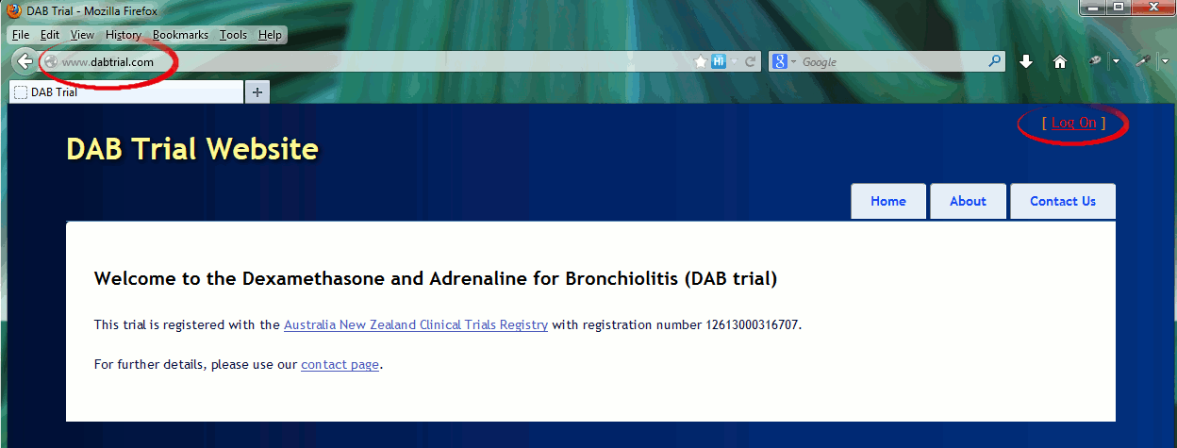Click Log On
10. Your screen should look like this:  
    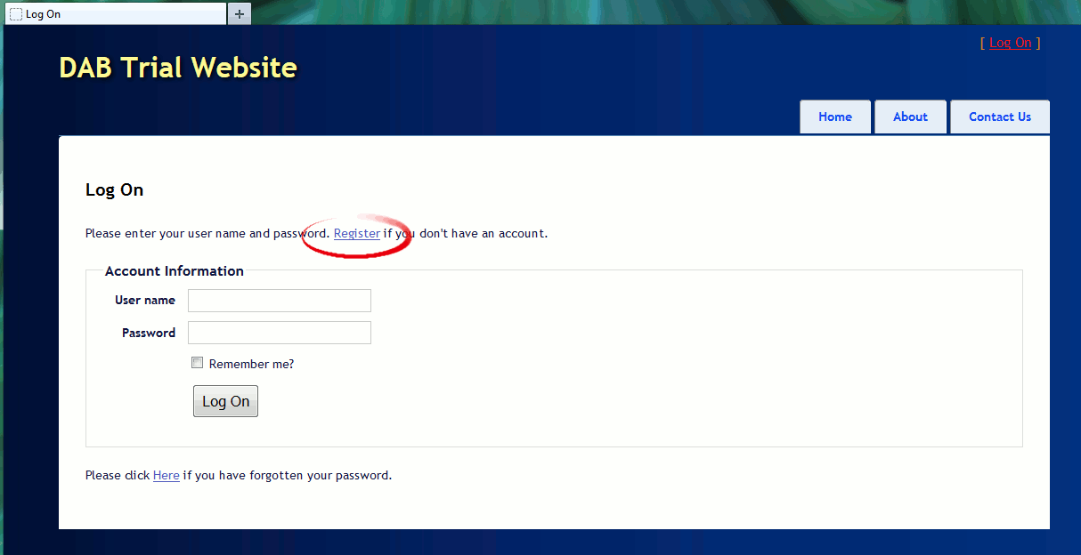  
    Click Register
11. Your screen should look like this:  
    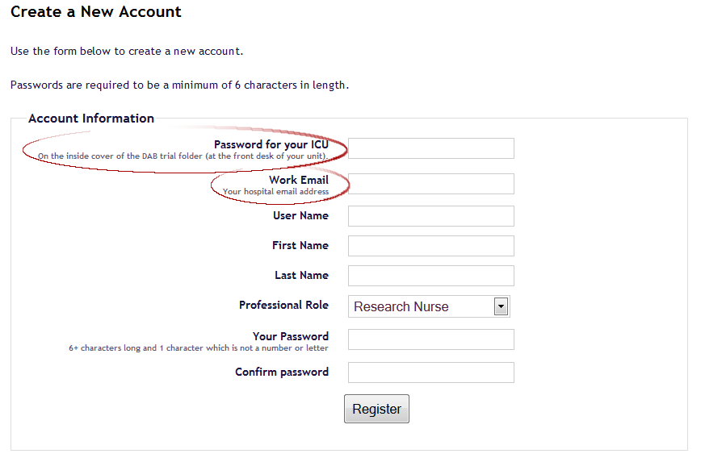
    1. The password for Starship PICU is **coffee2go;)**
    2. The email entered MUST BE your hospital assigned email (i.e. ending with @adhb.govt.nz, or if you are affiliated with the university of Auckland, you can choose to use your @aucklanduni.ac.nz email)
    3. In the final field, you are required to enter a personal password, to use if you need to log in in future, in order to view information about your patient at a later date, enrol other patients, register adverse events or protocol violations etc.
       1. Please choose something you will remember.
       2. Note 1 character is required to be neither a letter nor a number (e.g.one of #$.}).
       3. This password cannot be retrieved or viewed by anyone, but a new password can be generated and sent to the email you provided if you forget it.
12. Click Register. You will be redirected to the Enrol Participant page:  
    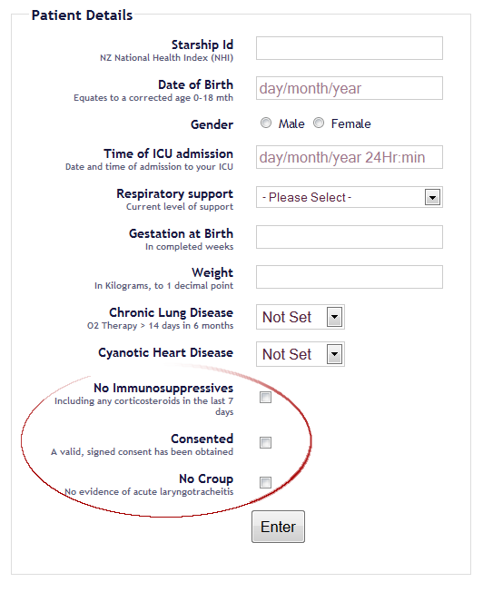
    1. The Inclusion and exclusion criteria are highlighted in yellow – please review them if you are unsure.
    2. Please read and answer all the questions very carefully. Many of the questions are used to ‘risk stratify’ the randomisation, and therefore **cannot be changed later**.
    3. The trial definition for a specific form of respiratory support will display here after it is selected from the drop down list.
    4. Each of the checkboxes here must be clicked prior to proceeding. Please read and tick ONLY if they apply to your patient.
13. Click Enter, and you will be redirected to:
14. Your patient has been randomised! Please note the arm they have been randomised to, and ensure the medications are prescribed accordingly (see the example medication chart in this folder).
    1. Double Check your dose calculations (in purple) against the dose calculations displayed.
    2. Please note and chart the stop times (in maroon) for each of the trial medications.

